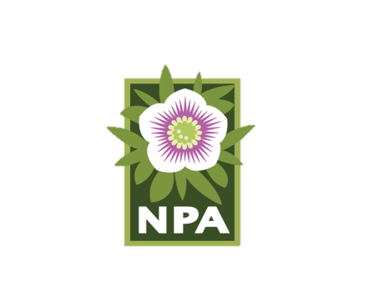

**NPA Open Gardens 2019**

**We would love to visit your garden!**

Touring gardens for inspiration, new ideas, and just plain fun is an all-time favorite of NPA members. The success of the Open Gardens program depends on the willingness of members to open their gardens for the rest of us to see.

*Will you be an NPA Open Gardens host in 2019?* While it takes some effort to get ready, it is so fun and rewarding. Garden hosts totally enjoy welcoming visitors, showing their garden, and connecting with fellow members who share their passion.

**Yes, your garden is worth visiting**

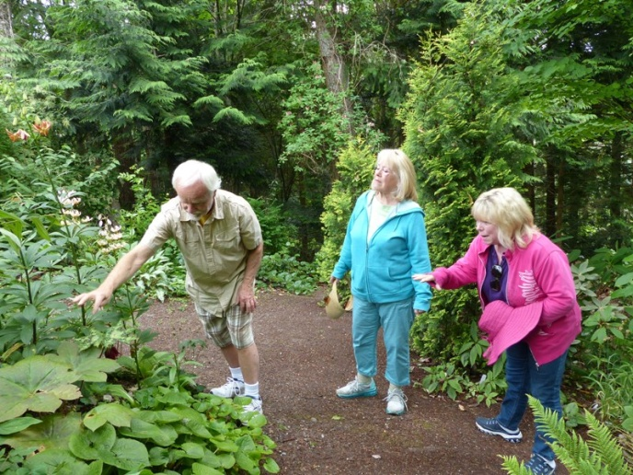The wonderful thing about gardens is that they are as varied as the gardeners who create them. Your garden is uniquely you. It’s your pride and joy, and members would love to see what you’ve created.

Should you have any doubt about opening your garden because you think that it needs to be “finished”, consider that gardeners learn as much from works-in-progress as from the “final” version (if indeed there is such a thing).

It doesn’t matter what kind of a garden you have – small or large, formal or cottage, rural or urban, new or well-established – it will be different from all the other gardens. People will want to visit.

*Garden of John Marsh, Marysville*

**Sign up now**

It’s easy to register your garden to be an Open Gardens host:

1. Go to NPA’s website at N-P-A.org, and click on Open Gardens tab to access and download the registration form.
2. Fill it out and email it to [npaopengardens@gmail.com](mailto:npaopengardens@gmail.com).
3. The deadline to register your garden is February 26, 2019.

Please see the reverse side of this insert for some brief registration tips.

**We look forward to visiting you in your garden.**